**Chaitanya Sambrani**

**PERSAGI (*Persatuan Ahli-Ahli Gambar Indonesia*)**

PERSAGI is the acronym for *Persatuan Ahli-Ahli Gambar Indonesia* (Union of Indonesian Painters, or to be more precise, Union of Indonesian Drawers). Founded by S. Sudjojono (1913-1986) and Agus Djaja (1913-1994) in October 1938, PERSAGI is widely understood to have played a major role in the development of modernism in Indonesian art. While there was no binding style linking the individual artists, they were all in search for a new art that was distinctively national and intensely individual. Sudjojono’s influence as critic and as well as artist was profound, and served to define a modernist as well as nationalist tenor in Indonesian art of the 1940s and beyond. In terms of its importance to Indonesian modernism, it is significant that PERSAGI was formed a decade after Bahasa Indonesia was declared the national language. It was in 1928 that young nationalists in the then Dutch East Indies led by Sukarno issued the Youth Declaration, proclaiming a unified nation with one motherland, one people and one language. The artists of PERSAGI saw themselves as cultural workers within this nascent nation-state, as part of a broad socialist-nationalist front aimed at the creation of a new national consciousness out of the inheritance of a colonial past, and the deeper histories that divided this archipelago-country with its vast geography and a variety of ethnic, religious and linguistic differences.

The group had twenty members, including among others Agus Djaja (chairman), S. Sudjojono (secretary), L. Setiyoso, Rameli, Abdul Salam, S. Sudiardjo, Saptarita Latif, Herbet Hutagalung, S. Tutur, Sindusisworo, T.B. Ateng Rus`an, S. Sastradiwirdja, Sukirno, Emiria Soenassa (the only woman artist in the group) and Suromo. Sudjojono was the chief ideologue and spokesman for the group. Emiria Soenasa is considered the first female artist of note in this period of Indonesian modernism.

**A vision for a new national art**

Calling for a renewal of Indonesian art, Sudjojono placed great emphasis on the individuality of the artist, honest expression and reflection of a national consciousness. He was critical of *Mooi Indië* (the Sweet Indies) romantic-academic work of artists such as Basuki Abdullah (1915-1993) who were accepted and valorised within establishment circles at the time. *Mooi Indië* artworks were characterised by paintings with landscapes and pastoral scenes, an attention to the picturesque in village life and folklore, including titillating renditions of the female body and legendary scenes. Sudjojono and his PERSAGI colleagues found these to be divorced from reality, in addition to being elitist, exploitative and non-confrontational in the context of continuing colonial domination. For the artists of PERSAGI, a shared feeling of community with common folk under colonial rule was markedly absent in these artworks. Instead, the vision Sudjojono articulated was one of revolutionary sentiment, resulting in a change of subject matter to guerrilla fighters, farmers, local people and working women rendered in modernist styles ranging from Impressionism to Expressionism. In some ways, these artists were responding to Baudelaire’s espousal of the modern as being fleeting, ephemeral and contingent, in the sense of requiring modern art to be responsive to the present circumstance and not subservient to inherited notions of aesthetic experience.

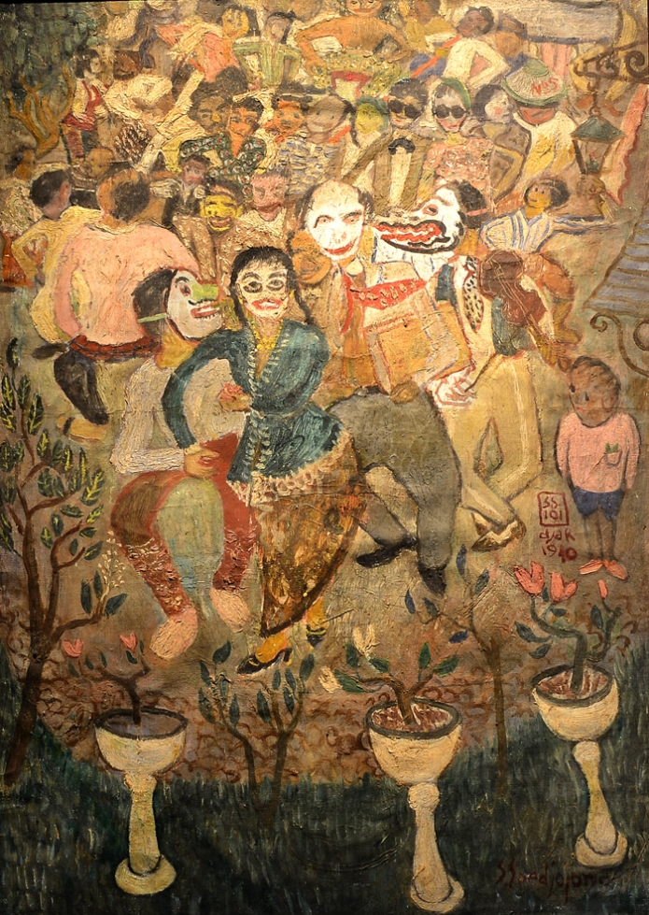

Sudjojono, *Tjap Go Meh*, 1940, oil on canvas, 73 x 51 cm, Galeri Nasional Indonesa.

The quest for an Indonesian identity that was both inalienably native and authentically modern was paramount in PERSAGI’s quest as articulated by Sudjojono. He called for artists to be truthful and courageous, regardless of public recognition. He emphasised the need for artists to be aware of, but also immune to public expectations of what beauty consisted of, and to be steadfast in the pursuit of representing Indonesian reality as it appeared to the artist, rather than via Orientalist notions of how this reality ought to appear.

**PERSAGI exhibitions and institutional contexts**

The artists of PERSAGI held their first exhibition in 1939 in a Batavia (now Jakarta) bookstore. Their application to exhibit at the *Bataviasche Kunstkring* (Batavian Art Circle, a colonial building designed specifically as an art gallery) was turned down. However in 1941 PERSAGI artists were invited to put on their second exhibition at the *Bataviasche Kunstkring* heretofore reserved for Dutch artists. This may be taken as evidence of the appreciation that the Dutch authorities governing the *Kunstkring* had developed for the work of the native artists. Also implicit in this decision were the growing pressures the Dutch were feeling from rising nationalism in Indonesia, as well as the spread of Nazism in Europe and the expansion of Japanese military domination in the Asia-Pacific.

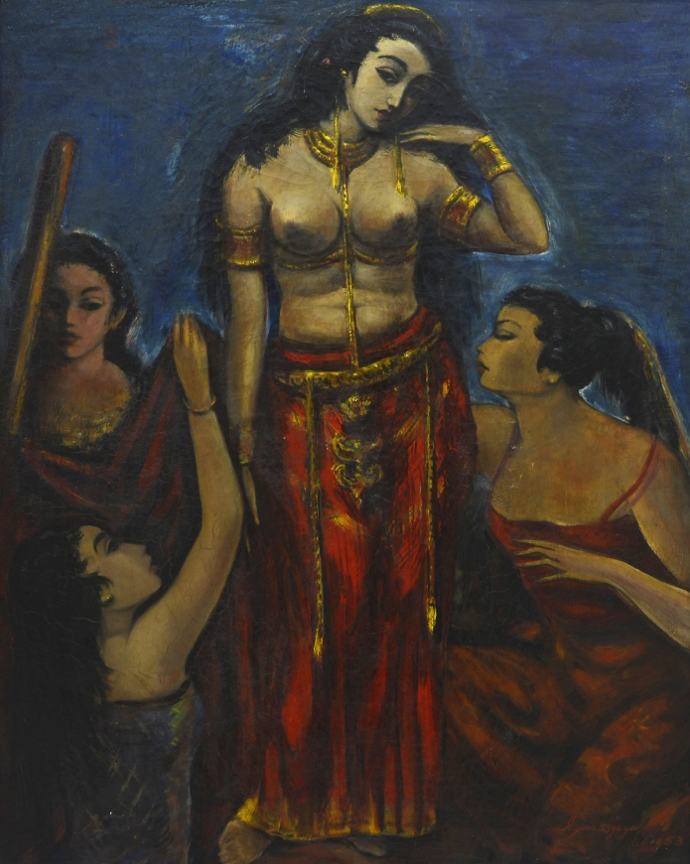

Agus Djaja, *Making up*, 1953, oil on canvas, 100 x 125 cm, Galerie Nasionale Indonesia.

The artists of PERSAGI were largely self-taught or informally taught. The first formal art schools in Indonesia were founded in Bandung and Yogyakarta in 1950 after total independence was realised in 1949 and more than a decade after PERSAGI came together. The Bandung school (now Fakultas Seni Rupa dan Desain = Faculty of Fine Art and Design) at the Institut Teknologi Bandung (Bandung Institute of Technology) was long associated with formalism, tending to Cubist and abstract art. The Yogyakarta school (Akademi Seni Rupa Indonesia = Indonesian Academy of Fine Arts), and now Institut Seni Indonesia (Art Institute of Indonesia) was more closely associated with Expressionism, magic realism and Surrealism, all of which allowed a firmer relationship with lived experience than the formalism of the Bandung school.

**Japanese occupation and the end of PERSAGI**

PERSAGI was effectively terminated with the Japanese occupation of Indonesia in 1942. Several of its members joined the *Keimin Bunka Shidosho (KBS)*, a Japanese cultural and propaganda organisation founded in 1943 with branches in several parts of Indonesia. The mission of *KBS* was to enlighten and educate the people through the arts. In addition to fine art, it supported literature, music and theatre. There is some continuity of concerns from PERSAGI to *KBS*, given that the Japanese vision of a Greater East Asia Co-prosperity Sphere made a claim to empowering colonised parts of Asia to gain a greater sense of identity. Over some two years of existence, *KBS* organised about a dozen exhibitions of Indonesian and Japanese artists in Jakarta, Malang, Solo and Bandung.

**References and further reading**

Holt, Claire [1967]. *Art in Indonesia*: *Continuities and Change.* Ithaca: Cornell University Press.

Fischer, Joseph ed. [1990] *Modern Indonesian Art*: *Three Generations of Tradition and Change 1945-1990.* Jakarta and New York: Panitia Pameran KIAS and Festival of Indonesia.

Indonesian Visual Art Archive, <http://archive.ivaa-online.org/files/uploads/texts/Untuk%20Lecture%20FAAM%20english.pdf>